43.64: a)
6.82 rad. b) (20)(6.82 rad)=136 rem 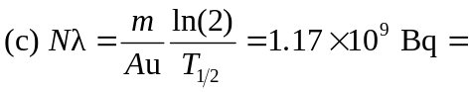
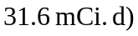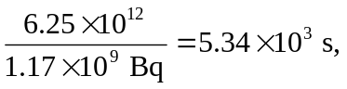about an hour and a half. Note that this time is so small in comparison with the half-life that the decrease in activity of the source may be neglected.

